**Assignment 10**

**--Qn1.Write a function to Calculate the total stock value for a given category:**

**-- (Stock value=ROUND(SUM(unit_price * units_in_stock)::DECIMAL, 2)**

**-- Return data type is DECIMAL(10,2)**

**QUERY DETAILS**

create or replace function get_stock_value_by_category(

in p_category_id int

)

returns decimal(10,2)

language plpgsql

as $$

declare

v_stock_value decimal(10,2);

begin

select

round(sum(unit_price * units_in_stock)::decimal, 2)

into

v_stock_value

from

products

where

category_id = p_category_id;

return coalesce (v_stock_value, 0.00);

end;

$$;

select get_stock_value_by_category(7);

select *from products where category_id =7

select count(*), unit_price , units_in_stock

from products

where category_id =7

group by unit_price , units_in_stock ;

**OUTPUT**

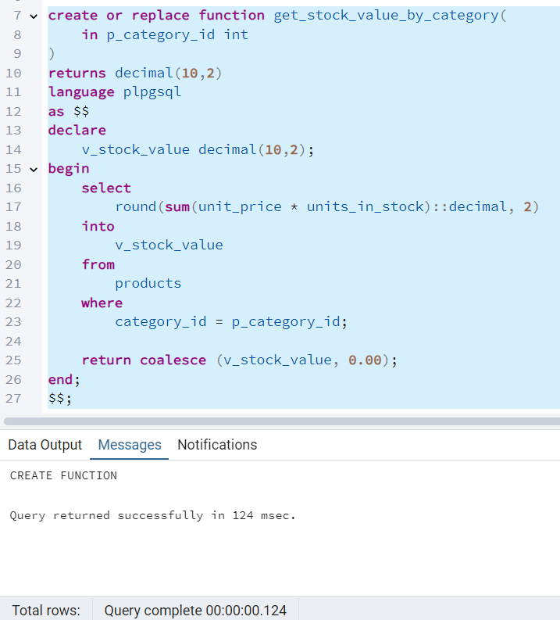

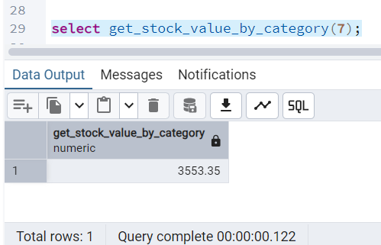

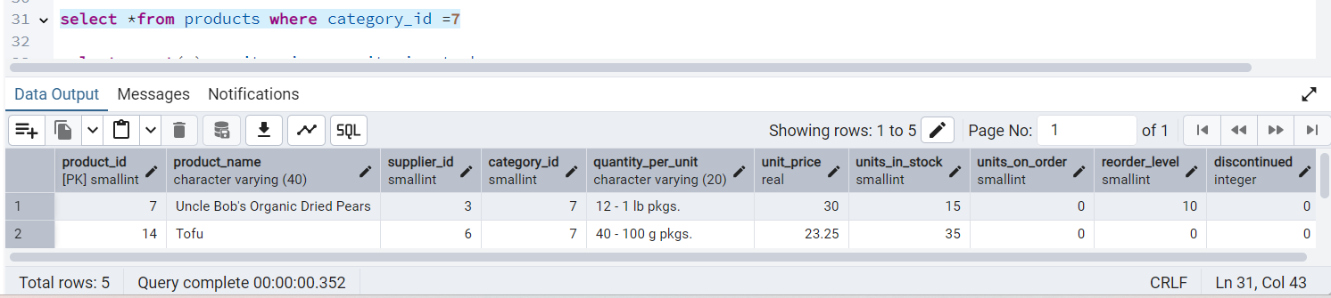

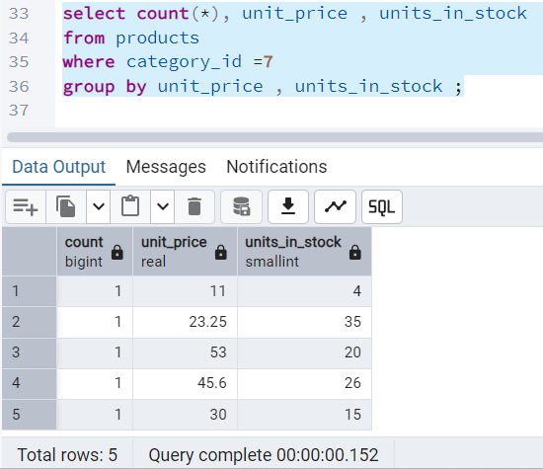

**--Qn2.Try writing a cursor query which I executed in the training.**

**-- This cursor will iterate through products and adjust prices based on units in stock**

**QUERY DETAILS**

CREATE OR REPLACE PROCEDURE update_prices_with_cursor()

LANGUAGE plpgsql

AS $$

DECLARE

product_cursor CURSOR FOR

SELECT product_id,product_name,unit_price,units_in_stock

FROM products

WHERE discontinued =0 ;

product_record RECORD;

v_new_price DECIMAL(10,2);

BEGIN

--open the cursor

OPEN product_cursor;

LOOP

--fetch the next row

FETCH product_cursor INTO product_record;

--Exit whn no more rows to fetch

EXIT WHEN NOT FOUND;

--calculate new price

IF product_record.units_in_stock < 10 THEN

v_new_price := product_record.unit_price * 1.1;-- 10% increase

ELSE

v_new_price := product_record.unit_price * 0.95;-- 5% increase

END IF;

--update the product

UPDATE products

SET unit_price = ROUND (v_new_price,2)

WHERE product_id =product_record.product_id;

--log the change

RAISE NOTICE 'updated% price from % to %',

product_record.product_name,

product_record.unit_price,

v_new_price;

END LOOP;

-- close the cursor

CLOSE product_cursor;

END;

$$;

--TO execute:

CALL update_prices_with_cursor();

**OUTPUT**

